10 EXTENSION SCIENCE BIOLOGY ASSIGNMENT: GENETICALLY MODIFIED CROPS 2015

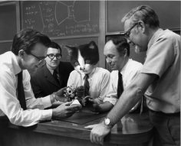

Name:__________________________ Teacher: Miss Cerny

Form:__________________________ Due date:___________

Aim: This assignment will allow you to research information about genetically modified food.

Hint: page 25-26 of your text book has information you can use as does your activity book. ☺

Plagiarism:
You must write in your own words not copy sentences word for word from another student or another source.
Plagiarising = instant zero on assignment and you will have to re-do it.

Assessment policy:
Have sick note/legitimate reason from parent = new negotiated due date.
Assignment not submitted on due date = -20% mark
Assignment not submitted on new negotiated due date = -40% mark
+ Letter home to parents.
+ Must attend academic completion to complete assignment.

If you are not at school the day this assignment is due, please email it to me by 4pm.

s.cerny@aranmore.wa.edu.au

What is genetically modified food? 3:13min
https://www.youtube.com/watch?v=JMPE5wlB3Zk
From watching this video, briefly describe what ‘genetically modified’ means. (1 mark)

_________________________________________________________________________________________________

_________________________________________________________________________________________________

_________________________________________________________________________________________________

_________________________________________________________________________________________________

_________________________________________________________________________________________________

Neil deGrasse Tyson on gmo food! 2:20min
https://www.youtube.com/watch?v=1ecT2CaL7NA
Neil deGrasse Tyson is an American astrophysicist, cosmologist, author, and science communicator.
Describe Neil deGrasse Tyson’s opinion on genetically modified foods. (1 mark)

_________________________________________________________________________________________________

_________________________________________________________________________________________________

_________________________________________________________________________________________________

_________________________________________________________________________________________________

_________________________________________________________________________________________________

Bill Nye on GMO foods 7:57
https://www.youtube.com/watch?v=8z_CqyB1dQo
Bill Nye is an a science educator, comedian, actor, writer, scientist, former mechanical engineer and television host. Bill Nye used to actually be against GMO foods but changed his opinion and now he is a strong advocate for the growth of GMO foods.
List five key pieces of information you take from this video. (1 mark)

_________________________________________________________________________________________________

_________________________________________________________________________________________________

_________________________________________________________________________________________________

_________________________________________________________________________________________________

_________________________________________________________________________________________________

_________________________________________________________________________________________________

_________________________________________________________________________________________________

_________________________________________________________________________________________________

_________________________________________________________________________________________________

_________________________________________________________________________________________________

_________________________________________________________________________________________________
1. In your own words, and in language you understand, write a few sentences that explains what genetic modification is. (3 marks)

_________________________________________________________________________________________________

_________________________________________________________________________________________________

_________________________________________________________________________________________________

_________________________________________________________________________________________________

_________________________________________________________________________________________________

_________________________________________________________________________________________________

_________________________________________________________________________________________________

_________________________________________________________________________________________________

_________________________________________________________________________________________________

_________________________________________________________________________________________________

_________________________________________________________________________________________________

Choose either GM canola OR Golden rice

Name of your GM crop: _______________________________________________

2. Explain how your chosen crop has been modified (changed).
What is a characteristic that is has now that it didn’t have before it was modified? (2 marks)

_________________________________________________________________________________________________

_________________________________________________________________________________________________

_________________________________________________________________________________________________

_________________________________________________________________________________________________

_________________________________________________________________________________________________

_________________________________________________________________________________________________

_________________________________________________________________________________________________

_________________________________________________________________________________________________

_________________________________________________________________________________________________

_________________________________________________________________________________________________

_________________________________________________________________________________________________

3. Describe two advantages of genetically modifying your chosen crop. (2 marks)

_________________________________________________________________________________________________

_________________________________________________________________________________________________

_________________________________________________________________________________________________

_________________________________________________________________________________________________

_________________________________________________________________________________________________

_________________________________________________________________________________________________

_________________________________________________________________________________________________

4. Describe four benefits of GM crops in general (not including the benefits you described in question 4). (4 marks)
_________________________________________________________________________________________________

_________________________________________________________________________________________________

_________________________________________________________________________________________________

_________________________________________________________________________________________________

_________________________________________________________________________________________________

_________________________________________________________________________________________________

_________________________________________________________________________________________________

_________________________________________________________________________________________________

_________________________________________________________________________________________________

_________________________________________________________________________________________________

_________________________________________________________________________________________________

_________________________________________________________________________________________________

_________________________________________________________________________________________________

_________________________________________________________________________________________________

_________________________________________________________________________________________________

_________________________________________________________________________________________________

_________________________________________________________________________________________________

_________________________________________________________________________________________________

5. Some groups of people are against genetically modified crops (anti-GM). Describe three claims these groups of people make against GM crops and for each one explain whether or not you think it is valid (rational, justifiable) and explain why/why not. (6 marks)

Claim 1: _________________________________________________________________________________________

_________________________________________________________________________________________________

_________________________________________________________________________________________________

_________________________________________________________________________________________________

_________________________________________________________________________________________________

_________________________________________________________________________________________________

_________________________________________________________________________________________________

_________________________________________________________________________________________________

_________________________________________________________________________________________________

Claim 2: _________________________________________________________________________________________

_________________________________________________________________________________________________

_________________________________________________________________________________________________

_________________________________________________________________________________________________

_________________________________________________________________________________________________

_________________________________________________________________________________________________

_________________________________________________________________________________________________

_________________________________________________________________________________________________

_________________________________________________________________________________________________

Claim 3: _________________________________________________________________________________________

_________________________________________________________________________________________________

_________________________________________________________________________________________________

_________________________________________________________________________________________________

_________________________________________________________________________________________________

_________________________________________________________________________________________________

_________________________________________________________________________________________________

_________________________________________________________________________________________________

_________________________________________________________________________________________________
6. Decide whether you support the continued use of GM foods in Australia and justify your decision (explain why). (2 marks)

_________________________________________________________________________________________________

_________________________________________________________________________________________________

_________________________________________________________________________________________________

_________________________________________________________________________________________________

_________________________________________________________________________________________________

_________________________________________________________________________________________________

_________________________________________________________________________________________________

_________________________________________________________________________________________________

_________________________________________________________________________________________________

_________________________________________________________________________________________________

_________________________________________________________________________________________________

_________________________________________________________________________________________________

_________________________________________________________________________________________________

_________________________________________________________________________________________________

_________________________________________________________________________________________________

_________________________________________________________________________________________________

7. Look at the following groups in Australia and state whether they are for growing GM crops in Australia or against growing GM crops in Australia. For each group, write a quote you found on the website that supports your answer. (10 marks)

Group | Pro-GM or anti-GM | Quote to support your answer
Crop Life Australia
www.croplifeaustralia.org.au/
Biotechnology Industry Organization
http://www.bio.org/
Producers Forum
www.producersforum.net.au/index.htm
Ag Bio World
http://www.agbioworld.org/
True Food Network
www.truefood.org.au/index.php

Reference list

Minimum of two references. (1 mark)
Minimum of two different sources. (1 mark)
(book, encyclopedia, video, website, journal, magazine, newspaper).
Referenced using the style below (the style in the diary is incorrect but I will not penalize you if you use it).
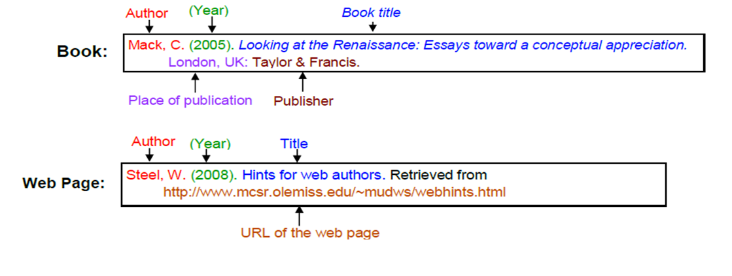
(1 mark)

If there is no author on the webpage, write the company/organisation name of the website instead. For example:

Sacred Heart Singing Music Department. (2008). Hints for web authors. Retrieved from http://home.olemiss.edu/~mudws/webhints.html

_________________________________________________________________________________________________

_________________________________________________________________________________________________

_________________________________________________________________________________________________

_________________________________________________________________________________________________

_________________________________________________________________________________________________

_________________________________________________________________________________________________

_________________________________________________________________________________________________

_________________________________________________________________________________________________

_________________________________________________________________________________________________

_________________________________________________________________________________________________

_________________________________________________________________________________________________

_________________________________________________________________________________________________

_________________________________________________________________________________________________

_________________________________________________________________________________________________

_________________________________________________________________________________________________

_________________________________________________________________________________________________
Assignment is neatly written or typed. (1 mark)
Correct grammar and spelling. (1 mark)
Scientific language used (1 mark)

Total mark: /38 %

Teacher comments:

_________________________________________________________________________________________________

_________________________________________________________________________________________________

_________________________________________________________________________________________________

_________________________________________________________________________________________________

_________________________________________________________________________________________________

